
Name: Ali Raza
Reg no: 9864
Subject: DBMS
Submitted to: Sir Zohaib Khan

Lab no 03

Introduction to Data Manipulation Language (DML) Commands and Creating a
Sample Database

EXTRA TASKS

Task no 01:
Create a table called salesman with the following structure.
Code:
SQL> CREATE TABLE salesman (
2 SAL_ID NUMBER(6),
3 NAME VARCHAR2(20) NOT NULL,
4 CITY VARCHAR2(10),
5 COMMISION NUMBER (3)
6 );
Output:
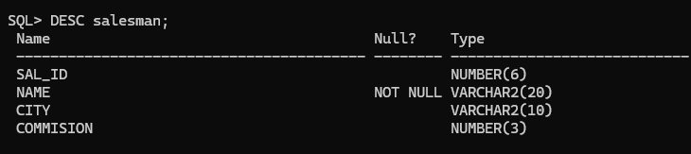
Inserting:
Code:
INSERT INTO salesman VALUES (5001, 'ALI RAZA', 'ISLAMABAD', 15);
INSERT INTO salesman VALUES (5002, 'Nail Knite', 'Paris', 13);
INSERT INTO salesman VALUES (5005, 'Pit Alex', 'London', 11);
INSERT INTO salesman VALUES (5006, 'Mc Lyon', 'Paris', 14);
INSERT INTO salesman VALUES (5003, 'Lauson', 'Paris', 200);
COMMIT;
OUTPUT:
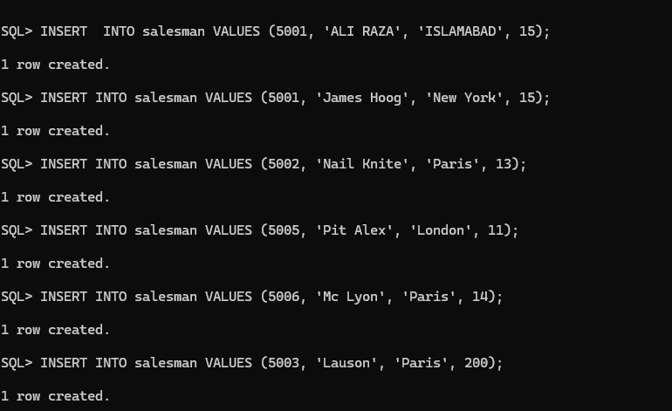
Commit:
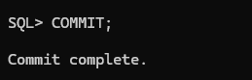
TASK NO 2:
Write a SQL statement to display all the information of all salesmen.
Code:
SELECT * FROM salesman
OUTPUT:

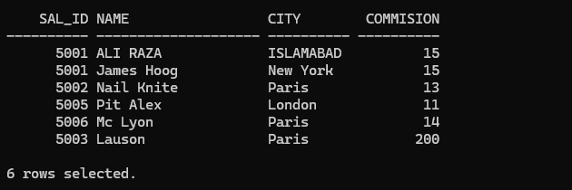

Task no 3:
Write a query to display three numbers in three columns.
Code:
SELECT 10, 20, 30 FROM dual;
Output:
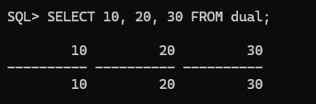
Task no 04;
Write a query to display the sum of two numbers 10 and 15 from RDBMS server.
Code:
SELECT 10 + 15 AS total FROM dual;
Output:

Task no 05:
Write a query to display the result of an arithmetic expression.
Code:
SELECT (10 + 5) * 2 / 3 AS result FROM dual;
Output:


Task no 06:
Write a SQL statement to display specific columns like name and commission for all the salesmen.
Code:
SELECT name, commision FROM salesman;
Output:
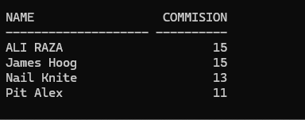
Task no 07:
Write a SQL statement to display names and city of salesman, who belongs to the city of Paris.
Code:
SELECT name, city FROM salesman WHERE city = 'Paris';
Output:
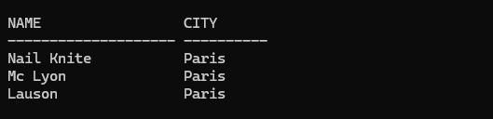

Task no 08:
Write a SQL statement to display all the information for those customers with a commission of 200.
Code:
SELECT * FROM salesman WHERE commision = 200;
Output:


Creating Table:
Code:
CREATE TABLE dept (
DEPTNO NUMBER(3),
DNAME VARCHAR2(20),
LOC VARCHAR2(20)
);

CREATE TABLE emp (
EMPNO NUMBER(6),
ENAME VARCHAR2(20) NOT NULL,
JOB VARCHAR2(13) NOT NULL,
DEPTNO NUMBER(3),
SAL NUMBER(7,2)
);
Output:
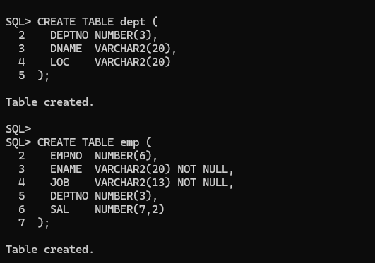
Describing:
DESC dept;
DESC emp;
Output:
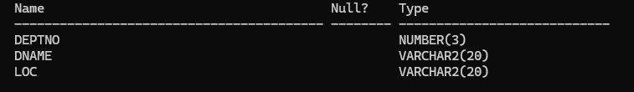

TASK NO 01:
Insert a single record into dept table.
Code:
INSERT INTO dept VALUES (1, 'CS', 'Karachi');
COMMIT;
SELECT * FROM dept;
Output:
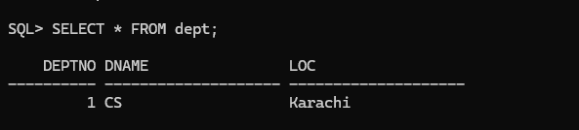
Task no 02:
Insert more than a record into emp table using a single insert command.
Code:
INSERT INTO emp VALUES (&empno, '&ename', '&job', &deptno, &sal);
Output:
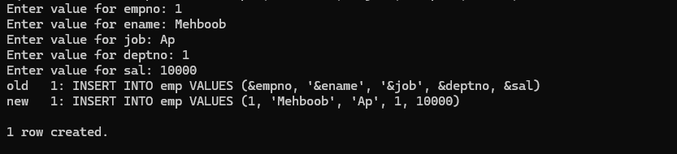
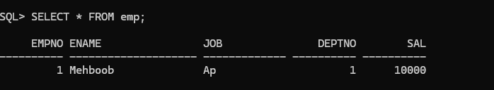
Task no 03:
Create a pseudo (copy) table employee with the same structure as the table emp and insert rows into the table using select clauses.
Code:
INSERT INTO emp VALUES (4, 'Kareem', 'PROF', 2, 30000);
INSERT INTO emp VALUES (5, 'Ayesha', 'AP', 1, 10000);
COMMIT;
SELECT * FROM emp;
Output:
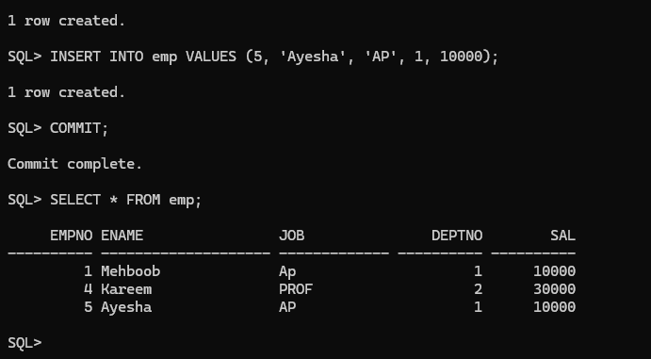
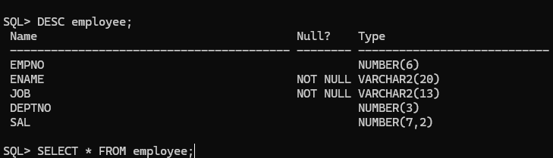

Task no 4:
Select employee name, job from the emp table.
Code:
SELECT ename, job FROM emp;
Output:
